Court jails 10, hundreds protest outside Mountjoy  Friday, Oct 10 2003, 11:56am  Yesterday the High court jailed 10 bin tax protesters. Last night at very short notice over 300 people protested outside Mountjoy jail where some of them were being held. On Saturday a Dublin Council of Trade Unions march will leave Parnell Square around midday to march on Mountjoy jail.  Bin Tax Protest High Court  Yesterday the High court jailed 10 bin tax protesters. Last night at very short notice over 300 people protested outside Mountjoy jail where some of them were being held.  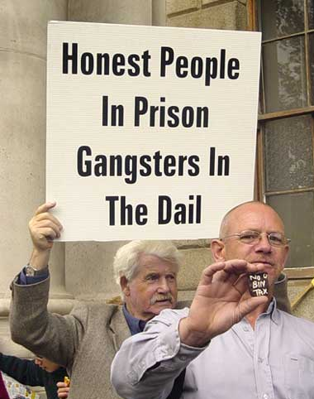  Anti-Bin Tax Rally  Monday 22nd Sept, 7.30 pm.  The Garden of Remembrance Dublin City  Well over 4,000 people took to the streets tonight to demand the release of Socialist Party TD Joe Higgins and Cllr Clare Daly and to oppose the bin tax. The march had been organised at a little over 24 hours notice but thousands of people responded to the call.  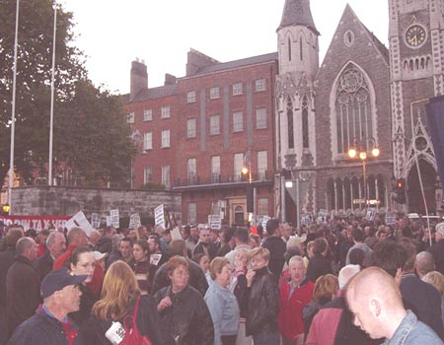  Monster meeting in Ballybrack + report from Dundrum  Friday, Sep 26 2003, 10:31am  100-120 people decide to follow trucks to "save" whellie bins from being siezed There was an excellent turn out for the meeting last night at Ballybrack workmans club – 100-120 people by my reckoning from all over Bally brack/Loughlinstwon – including Cooleven, Bayview, Pin wood, Ashlawn, Cromlech fields, Achill road, Sheleen, Glencar, River view, Laural Avenue, River Close, Loughlinstown road and watsons  Sept 24th 2003 - Report on the Dundrum Meeting against the Service Charges  The meeting last night was packed out with well over 120 people attending. The mood was angry and defiant. | “The ten jailings, mothers and grandmothers among them, represents the most significant attack on the right to protest seen in this country in a generation. In particular, they represent an attack on the right of working class people to protest- farmers, middle class professionals and other sections of society would never to treated in this way.”  Jailings will only intensify the protests against the bin tax Friday, Sep 19 2003, 8:20pm  THE JAILING of Joe Higgins T.D. and Cllr. Clare Daly for a month will not break the massive opposition in Dublin to the bin tax and to the draconian policy of leaving thousands of bins of householders boycotting the bin tax uncollected.  The following is the Motion passed at the delegate meeting of the Dublin Council of Trade Unions on Tuesday 7th October. One union (PSEU) spoke against the Motion which was, however, passed by all delegates with two abstentions.  “The Council condemns the imposition of Domestic Service Charges as unjust and a form of double taxation that particularly hurts PAYE workers and the disadvantaged; deplores the jailing of any person involved in peaceful protest and calls for the immediate release of persons so imprisoned, and resolves to coordinate an immediate campaign of protest, coordinated with other Trades Councils throughout the country at a date and a time to be determined by the Dublin Council of Trade Unions with a view to ending this inequitable form of taxation in our society, providing for proper funding of Local Government Services and opposing the privatisation of them.  That the Council will organise a demonstration, condemning double taxation and the jailing of bin tax protestors, to commence at Parnell Square at 12.00 noon on Saturday, 11th October.”  Sep 30 2003, 8:49am  In a Dáil motion tabled today Sinn Fein's five TDs accused the Minister for the Environment and Local Government Martin Cullen of implementing policies that have led directly to a situation of confrontation in Dublin and the imprisonment of bin charge protesters.  International Solidarity  Support has been widespread for the campaign, not only in Ireland but internationally. The past week has seen messages of support from Scottish Trade Unionists, the Scottish Socialist Party, one of the leaders of the Anti-Poll Tax movement in Britain and members of the Workers' Party (PT) in Brazil. There have also been small demonstrations at Irish Embassies in England, Sweden, Austria, Greece and Belgium  Students Unions  A number of Students' Unions have discussed the issue of the jailings of Joe Higgins TD and Cllr. Clare Daly, who is a former DCUSU President.  Friday, Oct 3 2003, 1:28pm  A group of Cork householders who were jailed by Cork City Council in relation to campaign against bin charges will visit Socialist Party TD Joe Higgins in Mountjoy Prison tomorrow (Saturday). Five Cork people were jailed on this issue in 1991 and seven more were imprisoned in 2001 | Carry on up the Gorman: Dublin City Council depot successfully blocked by anti bin tax activists  Friday, Oct 3 2003, 1:45pm  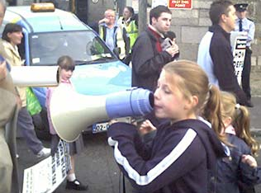  Altogether about 120 people took part. Of the 120 maybe 30 were in political organisations, the vast majority of the rest were local Stoneybatter and Cabra residents  Highlights were when two young girls got their hands on the megaphone and led the crowd in chants; the council officials attempt to read a certain document through a tiny megaphone which was completely drowned out by the 'no way - we won't pay' chants; and the sharing of two large pizzas among the picket.  Blockades and lobbies of Dublin city bin truck depots Wednesday, Oct 8 2003, 11:05am  The other blockade was taking place at Davitt road. We hear by mobile that a large force of Gardai had arrived there and proceeded to assault one of the blockaders. Workers in the depot came to their rescue saying they 'couldn't assault protesters like that and that they'd get the (Gardai) done for assault'. According to the report the police then got back in the vans and drove off.  Blockade updates  Thursday, Oct 2 2003, 5:58pm  Fingal:  The blockade lasted from 7 this morning until a little before 12 and covered all of its vehicle exits. Only one truck managed to get out of the depot in that period  South Dublin:  Yesterday residents in Palmerstown found a single truck attempting to implement non-collection and quickly blockaded it. More than 40 residents, mostly pensioners, held it all day and then overnight and into today. The last I heard (early this afternoon) it was still under blockade  Wednesday, Oct 1 2003, 3:44pm  ……. solidarity blockades in areas where bins are still being collected. In the last 10 days there have been up to 20 blockades in areas such as Cabra, Stoneybatter, East Wall, Finglas, the Liberties, Crumlin, Ringsend and Harold's Cross.  Wednesday, Oct 1 2003, 2:17pm  I was down at Rathsalagh(Shankhill) this morning, where we met the bin lorry. Before being allowed entrance to the Shanganagh Cliffs estate, the men on the trucks were asked if they were going to collect "all the bins", to which they replied:"yes".  