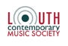
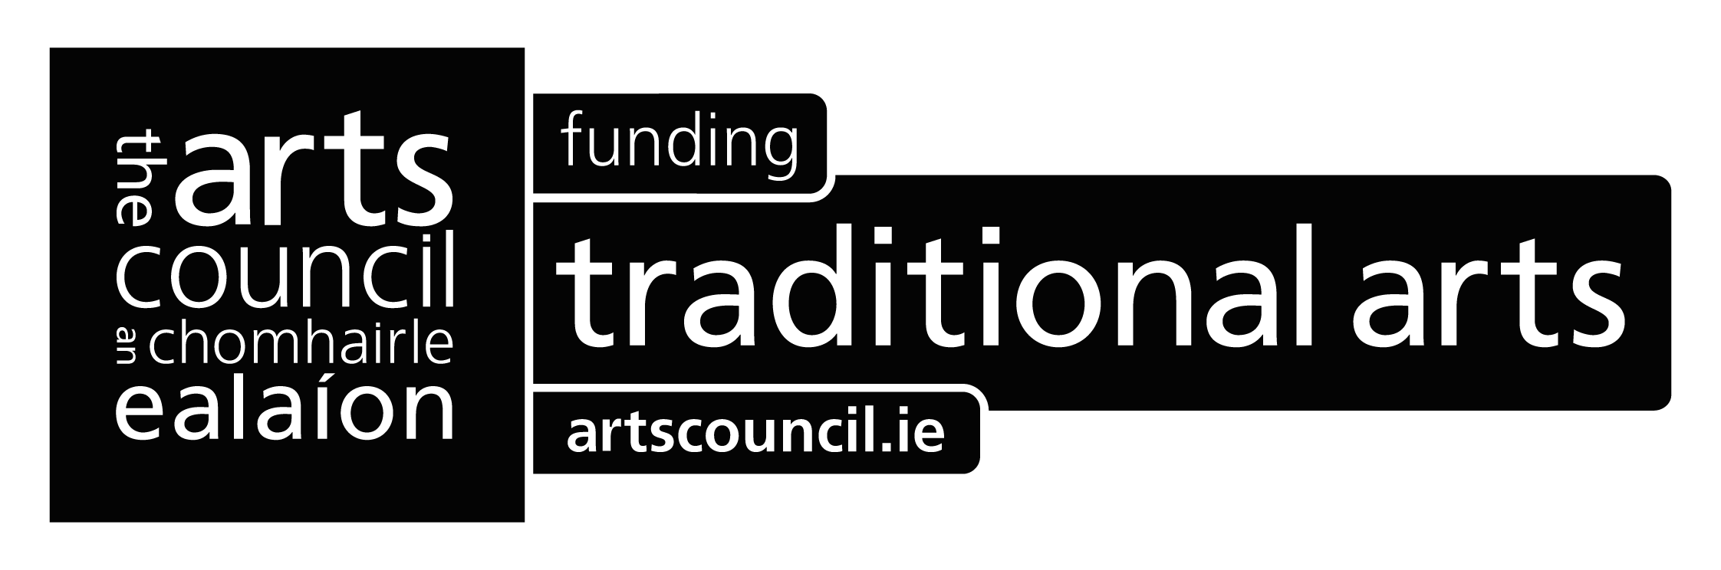
Press Release
Ó Riada Re-Imagined
Louth Contemporary Music Society in association with Temple Bar Trad Festival and Cois Cladaigh present a new arrangement of Seán Ó Riada’s Mass by Dmitri Yanov-Yanovsky performed by the EQ Singers with Zoe Conway on fiddle, Siobhan Armstrong on harp and Robbie Harris on bodhrán, conducted by Eamonn Dougan in St.Werburgh’s Dublin on Thursday 24 January 2013 and St. Nicholas' Collegiate Church Galway, on Friday 25 January 2013. Iarla Ó Lionáird will appear as a special guest for the Dublin performance.
The music of composer Seán Ó Riada, who is credited with re-igniting the popularity of Irish traditional music, is celebrated by Louth Contemporary Music Society (LCMS) in these unique performances of a new arrangement of his Mass in January 2013.
The new arrangement was completed by Dmitri Yanov-Yanovsky, a composer of international fame. A native of Tashkent, Uzbekistan, he most recently has been a composer-in-residence at Harvard University and Dartmouth College. Yanov-Yanovsky has received commissions from celebrated musicians including the renowned cellist Yo-Yo Ma and the Chicago Symphony Orchestra, the Kronos Quartet and Hilliard Ensemble. Yanov-Yanovsky’s music was first performed in Ireland at LCMS’s Sounds of the Silk Road Concert at Drogheda Arts Festival in 2011. Yanov-Yanovsky has arranged the mass for 16 voices, fiddle, harp and bodhrán.
The mass will be performed by the finest Irish professional singers in the newly formed EQ Singers, with Zoe Conway on fiddle, Siobhan Armstrong on harp and Robbie Harris on bodhrán. The choir and players will be conducted by Eamonn Dougan Associate Conductor of internationally renowned ensemble The Sixteen.
The performances will take place in St.Werburgh’s Dublin at 8pm on Thursday 24 January 2013 and St. Nicholas' Collegiate Church Galway, at 8pm on Friday 25 January 2013 . Iarla Ó Lionáird will appear as a special guest for the Dublin performance.
The Ó Riada Mass has been funded by the Arts Council’s Traditional Arts Touring Programme scheme and is financially supported by Foras na Gaeilge.
Further Information & listings see below or log onto: www.louthcms.org
LISTINGS INFORMATION:
St. Werburgh’s, Werburgh St, Dublin 2
Thursday 24 January 2013 | 8.00pm | €15(including booking fee)
Tickets – 01 7030709 | www.templebartrad.com
St. Nicholas Collegiate Church, Galway
Friday 25 January 2013 | 8.00pm | €15 & €12 Concession
Tickets: 091 756812 | www.coiscladaigh.net
FOR MEDIA INFORMATION OR PICTURES PLEASE CONTACT
Eamonn Quinn T: +353 86 2632408 | E: eamonn@louthcms.org

