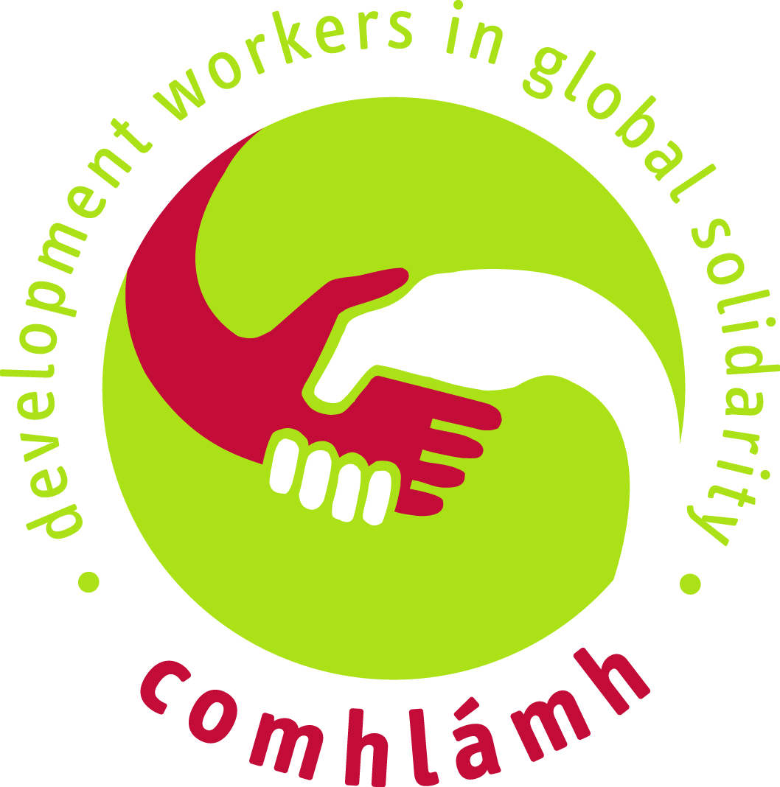
Comhlámh’s ‘What Next’?
A Course for Returned Volunteers

‘What Next?’ is a course for returnees who have lived and worked overseas in the capacity of learner, volunteer or development worker, and who are interested in continuing engaging in development education from Ireland.

What is covered?
The 4-day course will engage participants in a critical process to explore development issues and skills to raise awareness and take action locally. An outcome of the course is that participants will have the opportunity to develop and deliver an Action Project either individually or as a group around a particular issue or idea.

How much does it cost?
The course will cost €60 per person, which covers all training materials, accommodation costs, meals and refreshments.

When and where? Residential weekend of Sat 01st - 3rd of Mar 2013 : Cloughjordan Ecovillage, Tipperary
Saturday 13th Apr: The Sophia Centre, 25 Cork St Dublin 8
Saturday 08th Jun : The Lantern Centre, 17 Synge St, Dublin 8

How can I book?
To book please complete the online booking form at http://www.comhlamh.org/courses/booking.php?course=what-next
or for more information contact Susan by email susan@comhlamh.org or call 01-4783490 or visit: http://www.comhlamh.org/what-next-course.html

This course is run by Comhlámh, the Irish Association of Development Workers and Volunteers. Comhlámh campaigns, informs and educates on issues of social justice, human rights and global development.

To find out more about Comhlámh’s work or to become a member, please visit our websites: www.comhlamh.org or www.volunteeringoptions.org, or follow us on Facebook and Twitter.

Comhlámh, 2nd Floor, Ballast House, Aston Quay, Dublin 2 Tel: + 353 1 4783490 Email: info@comhlamh.org

