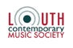
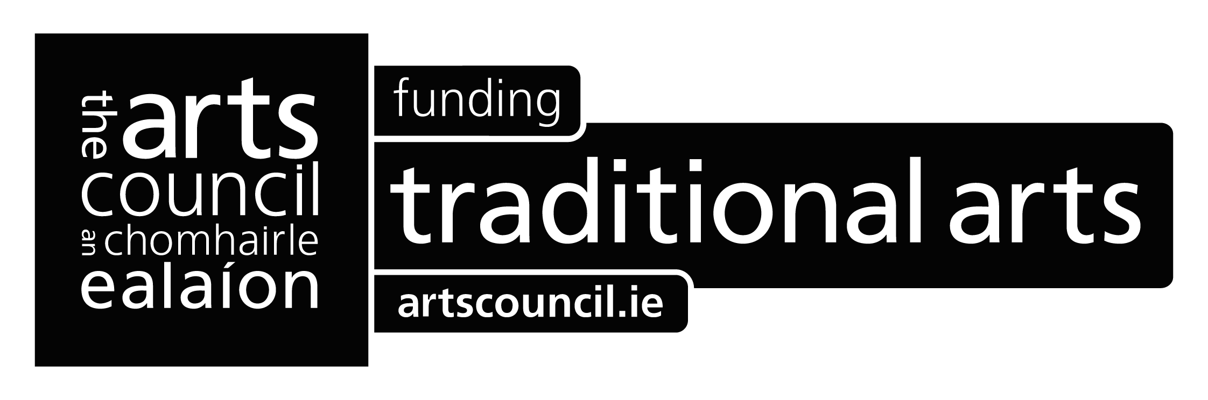
Press Release
Ó Riada Re-Imagined
Louth Contemporary Music Society presents a new arrangement of Seán Ó Riada’s Mass by Dmitri Yanov-Yanovsky performed by the EQ Singers with Zoe Conway, fiddle, Laoise Kelly,harp & Mel Mercier, bodhrán conducted by Eamonn Dougan with a special guest performance by Iarla Ó Lionáird in St.Nicholas’ Church of Ireland (The Green Church)Dundalk Saturday 10 March 2012
The music of composer Seán Ó Riada, who is credited with re-igniting the popularity of Irish traditional music, is celebrated by Louth Contemporary Music Society (LCMS) in a unique performance of a new arrangement of his Mass on 10 March 2012 in Dundalk.
The new arrangement was completed by Dmitri Yanov-Yanovsky, a composer of international fame. A native of Tashkent, Uzbekistan, he most recently has been a composer-in-residence at Harvard University and Dartmouth College. Yanov-Yanovsky has received commissions from celebrated musicians including the renowned cellist Yo-Yo Ma and the Chicago Symphony Orchestra, the Kronos Quartet and Hilliard Ensemble. Yanov-Yanovsky’s music was first performed in Ireland at LCMS’s Sounds of the Silk Road Concert at Drogheda Arts Festival in 2011. Yanov-Yanovsky has arranged the mass for 16 voices, fiddle, harp and bodhrán. The mass will be performed by the finest Irish professional singers in the newly formed EQ Singers, with Zoe Conway on fiddle, Laoise Kelly on harp and Mel Mercier on bodhrán. The choir and players will be conducted by Eamonn Dougan Associate Conductor of internationally renowned ensemble The Sixteen. The performance will take place in St. Nicholas’ Church of Ireland (The Green Church), Dundalk Co. Louth at 8pm on Saturday 10 March 2012.
Iarla Ó Lionáird will perform a selection of sacred hymns before the choral performance. It is fitting that Iarla Ó Lionáird will take part in this event. Iarla Ó Lionáird grew up in Cúil Aodha, Cork. His neighbour Seán Ó Riada was often in the Ó Lionáird home and the young Iarla was a member of Ó Riada’s choir, which he entered in childhood and remained in into his early twenties.
Additionally, Tomás Ó Canainn, author of ‘Seán Ó Riada - His Life and Work’, will give a talk on Ó Riada, his music and the masses in the Space,Town Hall Crowe St, Dundalk at 5pm on Saturday 10 March 2012. The talk is free but it is advised to book tickets in advance.
Eamonn Dougan, Associate Conductor of The Sixteen will be giving a choral workshop for amateur singers on the morning of the 10 March 2012. Singers will explore a selection a pieces while also working on warm ups, breathing techniques, stylistic advice, tuning and vocal blend. More details on the workshop are available by emailing choralworkshop@me.com.
Tickets for the concert cost €15 and are available from www.centralticketbureau.com.
The Ó Riada Mass has been funded by the Arts Council’s DEIS scheme and is financially supported by Foras na Gaeilge and Create Louth.
Further Information & listings see below or log onto: www.louthcms.org
LISTINGS INFORMATION:
St. Nicholas Church of Ireland (The Green Church), Dundalk, Co. Louth
Runs Saturday 10 March 2012 | 8.00pm | €15
Tickets – 0818 205 205 | www.centralticketbureau.com
FOR MEDIA INFORMATION OR PICTURES PLEASE CONTACT
Eamonn Quinn T: +353 86 2632408 | E: eamonn@louthcms.org
